|  |
| --- |
|  |
| MARKET ANALYSIS  Of Supply chain  BY  milan Prajapati  GitHub link (https://github.com/itsMilan1999/Market-Analysis-Of-supply-chain) |

* **Industry Category: Management and administration.**
* **Trends: This data describes a detail of the store supply management system and suggest some good solutions, for making more profit by analyzing various transactions of the organization.**
* **Stability: Data is analyzed by taking sales details and current market needs so it is beneficial for making future decisions.**

Businesses all compete in one way or another. It may be with specific, direct competitors or it may be with the way customers have been doing things for a long time. They solve their problem in a different way. When identifying the competition, you should identify who else is providing products or services to solve the same problem you are addressing? What are your business’ advantages over these competitors? How will your voice be heard over the noise of competitors? Sometimes a business plan includes a matrix of features and compares how each business offers or doesn’t offer those features. This section should reflect how your solution is different and better suited for the target market you have identified than the competition.

Developing a Market Analysis for a new business provides an entrepreneur a better understanding of the size and specific segments of a market, as well as an evaluation to determine if the target market will support the business’ growth plans. The Market Analysis is a critical part of any business plan created, whether to inform the business or to communicate to potential investors the size of the opportunity. This analysis documents an overview of the industry that your business will participate in. As you narrow this sector down to the ideal customer based on your business strategy, you will define your target market. A detailed description and sizing of the target market will help the reader understand the market value you are pursuing (the number of potential customers multiplied by the average revenue for your product or service).

In defining the target market, you will identify key elements such as geographic location, demographics, buyer characteristics, your target market's needs and how these needs are being met currently. If there are any direct competitors, these should be compared to how your offering will solve it in the future.

**Market Segmentation:** The below figure shows the total transactions and profit loss made in the market, Density of the graph describes the complexity and amount of data that are used for analysis.

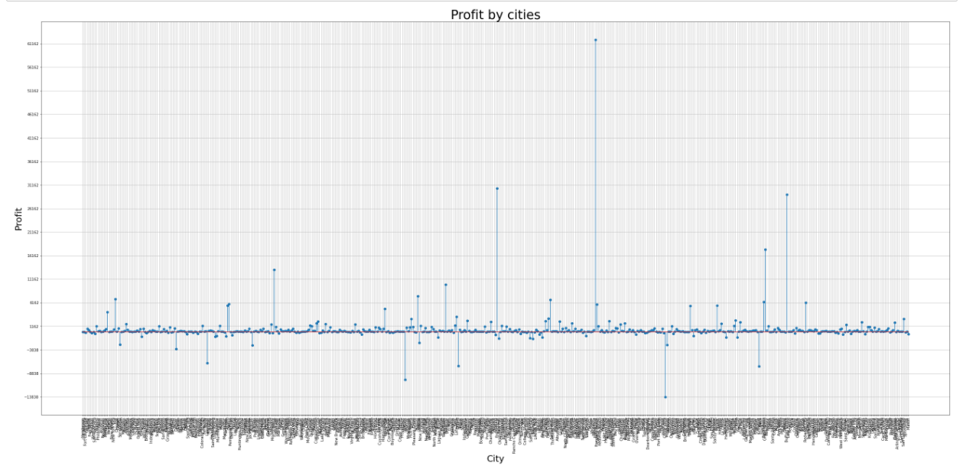

In this analysis, every possible part of the United States is included and more than 20000 Previous years Records are used for creating better results. This graph describes how some cities make an excellent profit while others are in the opposite section.

* Most profitable and loss-making Section

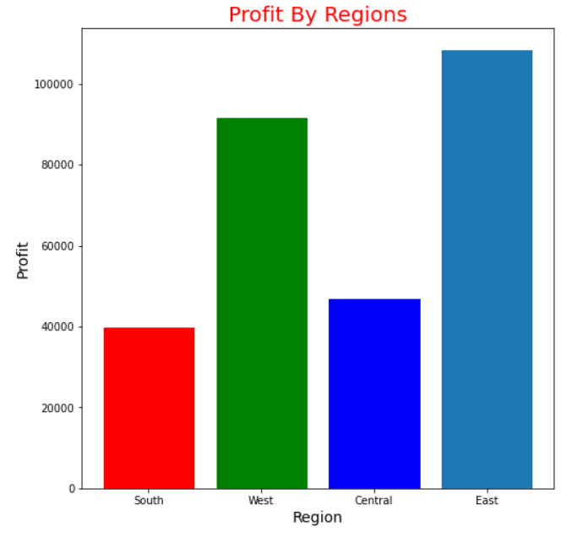

The above Bar graph shows that by doing business in East part of united states, Company gets Highest Profit followed by West and Central Part, this graph also shows that states located in the south region of United States contribute a very low amount in the profit of the company.

**Suggestion**: for more profit invest maximum amount in East sates and try to enhance customer support and facilities in South part

**•** Now further analysis of data will provide micro details of supply condition and profit loss in each individual state according to their location.

**•** For the deep, accurate, and better visualization, cities are divided into four sections central, south, east, and west which provide detail about the highest and list profit-making stores in the USA.

**•**Bellow four subgraphs describe which city is contributing most in company profit and in which stores are loss-making.

**•**According to this data in the South region, Virginia and Georgia are performing really well while outlets located in North Carolina and Florida are not contributing much to company profits but on the other hand in central states, Minnesota, Indiana, and Wisconsin are making more income as compared to any other stores located in the same region.

**•**Evident from a quick glance revealed that in central America, outlets located in Texas is making a huge loss and, East Region branches situated in New York is making a noticeable profit.

|  |  |  |
| --- | --- | --- |
|  |  |  |

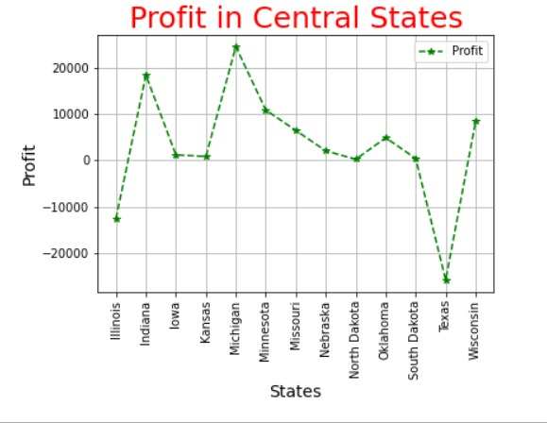 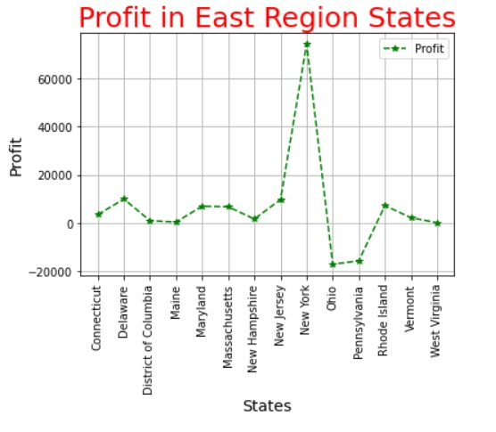

**•Suggestions:** Redirect more funds and facilities in cities like New York for more business expenditure and improve the facilities and customer service in locations like Illinois and in Ohio and provide more lucrative offers in loss-making outlets to improve sales

* Profitable and loss-making Individual Section

**•**Bellow figures describe which particular section makes maximum profit and sales.

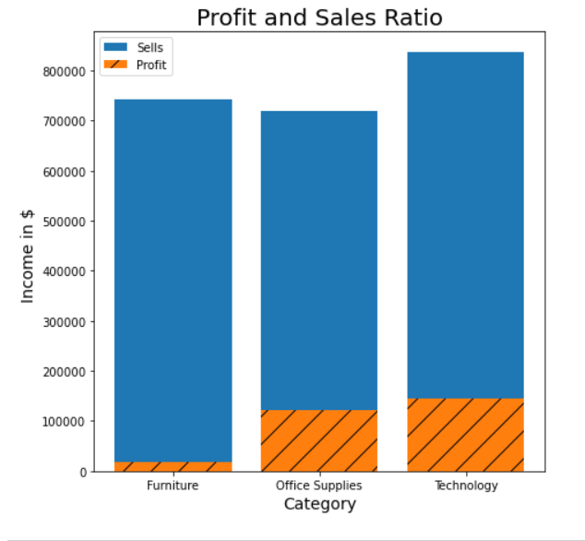 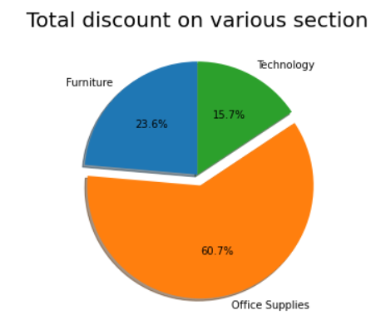

**•** Products come under technology section such as mobile phones, Screen guards and many other modern gadgets help the most in increasing organization sales and in the technology department profit is also highest as compared to any other products so to maximized profit company shout focused more on selling electronica items while on the other hand furniture section are also contributing good amount in sales but after import cost and other expenses the margin and profit are a least in the furniture section and this section required more space.

**•**The pie chart shows the amount of discount imposed on a particular section for increasing the sales of products and as per data maximum discount is offered on office products while list discount is offered on technology section and despite least discount technology section contribute more in organization profit.

* Product Sales

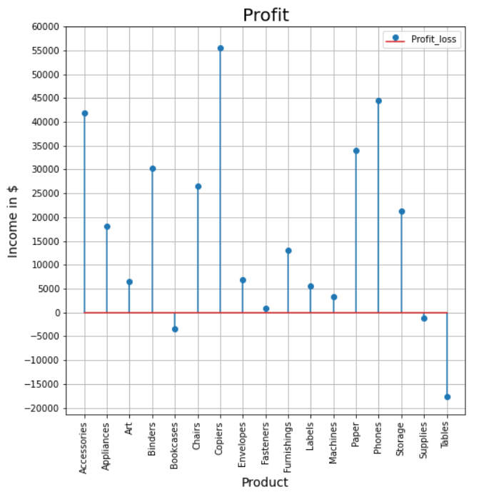 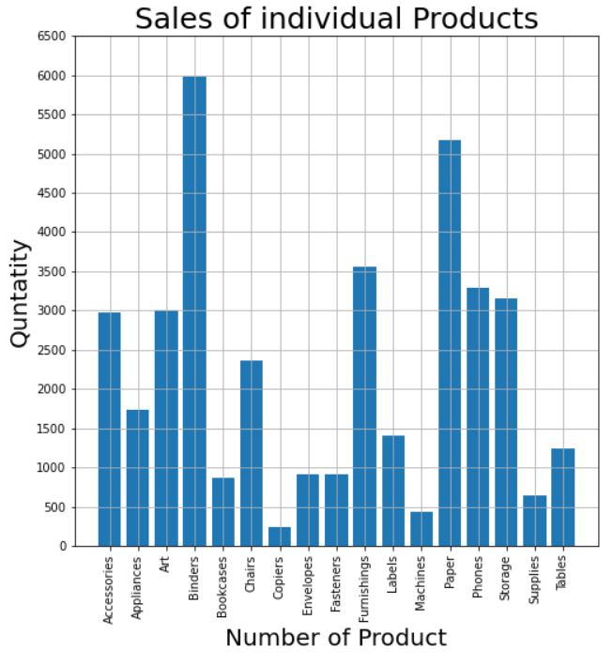

The above data describe the sales of particular product and amount of profit generated by selling particular product across all-region in united states, the data also shows the hidden information such as total sales of a particular product and profit from that same item after deducting all other costings.